On clicking the International Office tab under Christ University website, the following international office Home page should open

Home /About

CHRIST (Deemed to be University), a premier educational institution, is an academic fraternity of individuals dedicated to the motto of Excellence and Service. **The University welcomes students from all over the world to a vibrant environment of religious and racial harmony, secularism and cultural diversity.**

The decision to study abroad is a life-changing one which allows students to take on a personal journey as well as an academic one. CHRIST (Deemed to be University) is a fascinating place to study and we hope that you will decide to join us. In our eyes, internationalism signifies awareness, tolerance and understanding; to learn languages and discover cultures; to develop personally and professionally.

The International Office is responsible for informing, advising and supporting students, staff and lecturers on all matters related to internationalism.

We offer help in finding suitable programmes and guide you through the application process. 

We also provide support to our international students and guests of the University.

The International Office is entrusted with managing the University’s international relations and the welfare of its international students.

Staff

Details need to be updated

International Students

1. Living in Bangalore

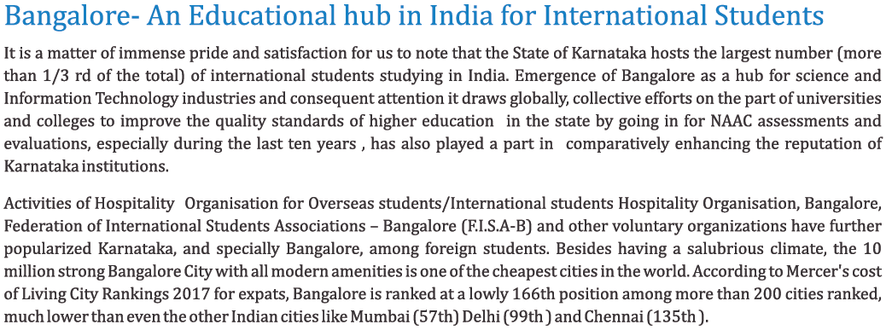

1. Admissions

This page should display information’s related to admission process for international student category. The present link of the CU website is given below

<https://christuniversity.in/international-student-category>

1. English Language Requirements

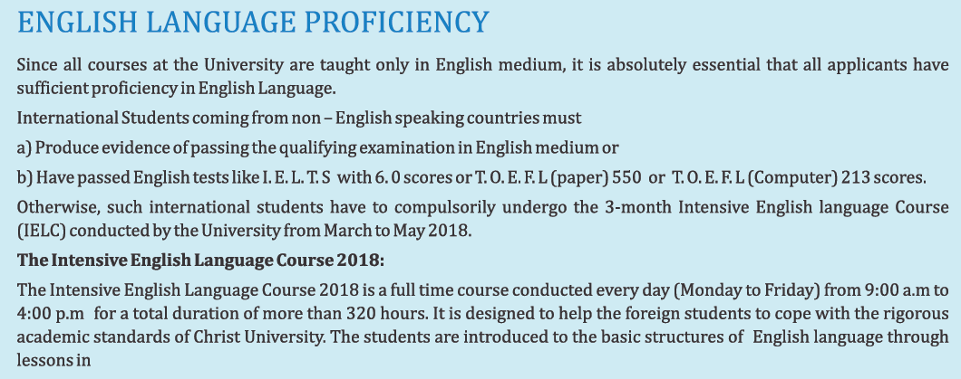

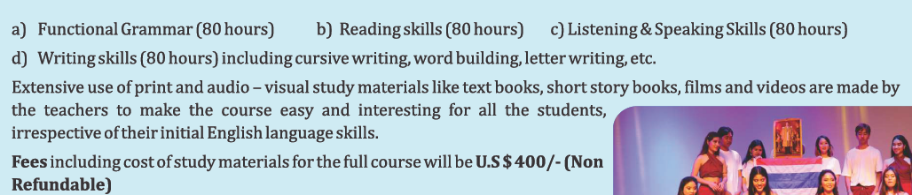

1. Accommodation

University offers a variety of accommodation options for students, located around and close to the campus, to suit different needs and budgets. Students are free to choose the lodging which suits them best.

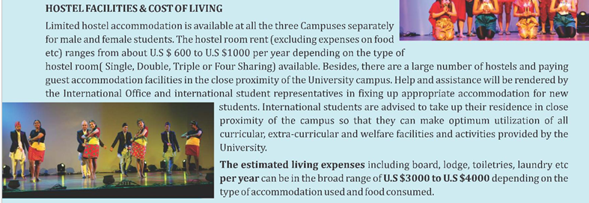

Student Hostels - The present link of the CU website is given below

<https://christuniversity.in/student-accommodation>

5. Special Regulations

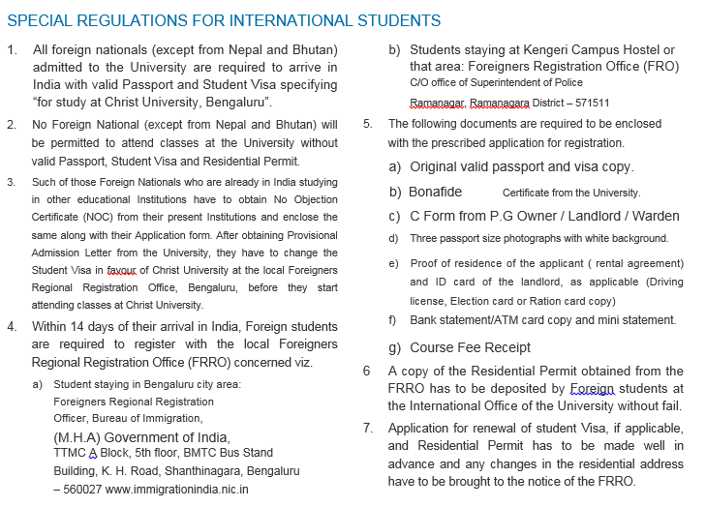

1. Campus Life at CHRIST (Deemed to be University)

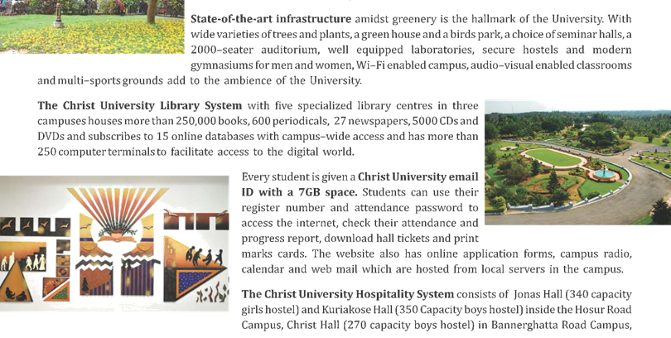

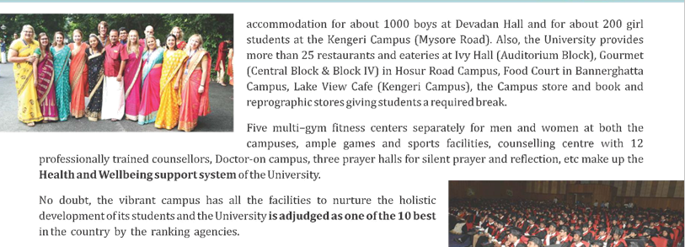

Insert few YouTube campus videos, perhaps the ones in which students talk about their day in campus

1. Collaboration Centers
2. Federation of International Student Associations, Bangalore (F.I.S.A.B)

To meet foreign students studying in other institutions and nationals from your own country, you are advised to be in close touch with F.I.S.A-.B who together with ICCR organizes various activities for foreign students.

Address:

F.I.S.A.B

C/o ICCR

26/3B, Sankey Road Cross,

Bangalore –560052

1. International Students Hospitality Organization (ISHO)

ISHO organizes get together with local families, awards Kanthula Prizes to meritorious International students and celebrates Indian festivals like Deepavali. It also conducts Indian language courses for the benefit of foreign students studying in Bangalore. They also have an interesting website on Bangalore full of useful information for foreign students. You may visit them, especially on a Saturday, at the following Address: I.S.H.O –“RAVSHAN” Ground Floor,

Address:

Ashley Road, Brunton Road Cross,

Off MG Road, Bangalore - 560 025.

Contact person:

Mr. K Ravi Shankar, Co coordinator.

Telephone: 98450-21434 / 25550221.

Email: isho.inka@gmail.com / kayares@gmail.com.

Website: [www.ishoinka.org](http://www.ishoinka.org)

1. Cultural Evening (All Friday's)

Every Friday cultural evening programs are organized for foreign students at Yvanika.

Address:

Yvanika,

State Youth Centre, Nrupatunga Road,

Bangalore –560 1. (Near State Reserve Bank of India)

Study Abroad / International Exchanges

1. CHRIST (Deemed to be University) International Profile

State In its quest for achieving World Class University standards, the Christ University strives to identify, adapt and put into effect the best educational and administrative practices of other reputed Universities in India and abroad. It has signed more than 50 MOU’s with Foreign Universities for exchange of students and teachers, conduct joint research and publication, programmes, organize joint seminars and conferences etc.

Regular exchange of students under various schemes like award of duel degrees, twining arrangements are arranged with about 15 active Universities in U.S.A, UK, Europe, Korea and Australia. Every year 200 students in each direction are exchanged for study periods extending from a few weeks to 2 semesters between Christ University and the partner University abroad.

Christ University is only University adopted by the 25 member Universities Study Abroad Consortium (USAC) of U.S.A for hosting short term U.S students in India. For this purpose Christ University maintains specialized units with qualified staff to run these exchange programmes.

Besides hosting exchange students for short periods ,the Christ University admits around 250 foreign students every year to its regular undergraduate, post graduate , and research programmes .At present , about 600 foreign students from more than 55 Asian ,African, European and North American countries are on the regular rolls of the University.

The International Office of the University has, over the years, evolved an elaborate system to attract international students to its various courses without taking recourse to unhealthy practices like appointing agents or consultants abroad. A student from abroad has the facility to apply on-line to any of the courses of the University through the user friendly University website and selection interviews are conducted over telephone /Skype and thereafter provisional admission letters and visa instructions are sent to the student without making the student come to the University.

Annual subscriptions are taken for two International internet magazines viz Daijiworld.com(Dubai) and Masterstudies.com(Norway) to disseminate information about the various courses offered by the University which are linked with the University website .

Concessional tuition fees (as compared to other foreign nationals) are charged for the nationals of SAARC and African countries to encourage students from less developed countries to join the University. 3 month Intensive English Language Courses are organized every year in the months of March to May (before the commencement of regular courses) for students coming from non English Learning background so as to equip them to follow lessons in English without any difficulties.

Arrangements to receive the newly admitted foreign students and temporarily accommodate them in transit hostels and provide assistance in procuring regular hostel etc are also made by the International office .They are also assisted with the registration formalities with the local Foreigners Regional Registration office by the International Office.

A well laid out programme to integrate the diverse international student community with the mainstream Christ University campus culture is put into practice by organizing a welcome get together ,exclusive orientation programmes for newly joined foreign students, encouraging them to participate in University events like Bhasha Utsav, Ethnic day , World Tourism Day, Dance Day, Sports & Games events etc. Information about medical and health aspects, food and nutrition etc are passed on through the Campus Doctor so as to enable foreign students to lead a healthy life while in India.

The International office also monitors the academic progress of the International students with the help of teachers and counselors and arranges for remedial classes as and when necessary. It also encourages merit students by giving awards and prizes for securing distinctions in semester examinations, part scholarships/fee concessions for higher studies for such students etc.

As a policy , foreign students are encouraged to go in for higher studies at our University or elsewhere and also remain in touch with International office even after completion of their studies .Graduated students are encouraged to join the Alumni Association units in their respective countries .Informal Christ University Alumni Association units are being formed in countries like Thailand, Nepal, Maldives, and South Korea .There seems to be good appreciation for the work undertaken by the International Office of the University in a few countries abroad as for example ,Government of Maldives sponsors a few of their official candidates for study at Christ University every year. Also, the United Board for Christian Higher Education in Asia has started placing their sponsored candidates at Christ University for higher studies from this year onwards.

1. Global Links / Partner Universities

CHRIST (Deemed to be University), Bangalore, India was established in 1969 with the Vision of “Excellence and Service” as an undergraduate College to cater to the higher education needs of the local communities. Given its quality of education and growth, the institution grew in size and stature resulting in Government of India conferring the University status to the Institution in 2008. The University offers Bachelor, Master and Doctoral courses in Humanities, Social Science, Science, Commerce and Management, Law, Education, Engineering, and Architecture.

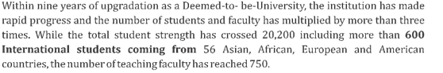

The University has long standing collaborations with organizations and institutions across the world. In the U.S. the University began its collaboration with Western Michigan University, Kalamazoo in 1997. Since then collaborations in the U.S. have spread to Virginia Commonwealth University, Richmond, Virginia; Catholic University of America, Washington, D.C.; University of Mount Union, Ohio; Miami University, Oxford, Ohio; University of Massachusetts, Boston and Amherst; and University Studies Abroad Consortium, Reno, Nevada. The University also has longstanding collaborations with the Universities in UK, Germany, Netherlands, Sweden, Switzerland, Australia, Hong Kong, Korea, Taiwan, and Japan among others.

Show a pictorial representation of World Map pointing the above collaborating locations

Need to create a partner search option something similar to the link shown below.  
​​

<https://han.moveon4.com/publisher/8/eng>

1. Collaboration models

The academic, social, personal and cultural benefits of participating in the exchange programme are huge. It can be challenging to live away from home and study in another country but it can also offer you a unique opportunity to travel, meet new friends and study subjects that may not be offered at your home university. Following are the models of collaborations the CHRIST (Deemed to be University has with various institutions.

1. **Credit Transfer:** CHRIST (Deemed to be University), (CU) studentsgraduate from the collaborating University after completing required years of study and acquiring required credits. CU students pay their fees for first two years/one year to C.U. and next two years/ one year to collaborating university. Collaborating University offers fee concessions/scholarships to CU students.
   1. 2+2 Bachelor Degree Course: The Students pursue two years of undergraduate study at Christ University and transfer credits to the collaborating host university in the
   2. 1+1 Master Degree Course: The Students pursue one year of master courses at CU and transfer credits to the collaborating host university in the
2. **Student Exchange:**
   1. CU students visit collaborating University for two weeks for exposure or collaborative programs. C.U. Students look after the travel expenses. collaborating institution looks after accommodation and subsidized food.
   2. Collaborating University Students come to C.U. C.U. looks after the accommodation. The exchange students do joint programs with C.U. students such as joint theatre performances, collaborative service learning or internships.
3. **Faculty Exchange:**
   1. Faculty members from the collaborating university come to CU for two weeks to eight weeks. Christ University looks after their accommodation and local transport. Faculty members from the University can come from any faculty any time of the year, from June through March.
   2. CU faculty members visit collaborating university from mid-March though the first week of May. CU looks after their travel. The collaborating university takes care of their accommodation and provides subsidized food.
4. **India Gateway Program:** students from the collaborating university come to CU with one or two faculty members. CU offers tailor-made courses on business, culture and society in India, involving lectures, field trips and industry/corporate visits. The group can have minimum of 15 and a maximum of 25 students. The program is paid for by the students of the collaborating university.
5. **Research:** Faculty members of Christ University and collaborating University write joint research, social impact or creative projects. The research projects may also involve students.
6. Student Exchange programs

Faculty exchanges for short duration

* OIAS facilitates faculty exchanges for 6-10 days with partner universities
* Itinerary is prepared for the visiting faculty.
* Visiting faculty are provided accommodation at CHRIST Guest House
* Airport transfers/local transport is arranged for the faculty.
* Sessions/lectures are delivered by the visiting faculty members.
* Faculty members from CHRIST are also given similar facilities at partner universities

1. Master’s Program

**Study abroad & get foreign university degree (1 year to 2 years)**

OIAS has tie ups with several foreign universities, where students get international exposure and degree from renowned foreign universities. Under the credit transfer program the students pursue first 2 years at CHRIST and then they are transferred to foreign university. Fliers are prepared and circulated among the students.

* Interested students can approach the Office for collecting the Application form.
* Once the student finalizes the University, the filled application form is submitted to OIAS
* The applications are screened to meet the eligibility
* The selected students are informed through email
* A small amount of processing fee is charged from the students. Students collect the challan from OIAS and pay the processing fee in the South Indian Bank.
* Letters/application forms are sent to universities and documents required for the visa purposes are procured from the foreign universities.
* Students are guided on the visa process.
* Students approach the consulate for visa appointment.
* Once the visa is received, the Clearance Form is submitted to IPM.

CHRIST (Deemed to be University) offers several international programmes. Below are the details some of them :

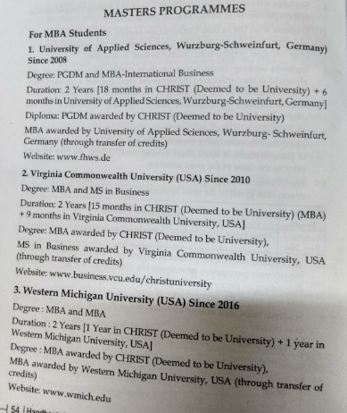

1. Undergraduate Credit Transfer Programmes

Short duration exchange programs (1 month to 6 months)

* The application forms are issued to the interested students
* The respective departments shortlist the candidates and informs the office.
* Orientation is provided to the selected students.
* Students collect the challans for payment of processing fee
* OIAS facilitates the transfer process by getting the required documents for visa purpose.
* OIAS guides the students on visa procedures.
* Once the course is completed the student receives the transcript
* CHRIST issues mark card by accepting the credits at foreign university.

CHRIST (Deemed to be University) offers several credit transfer programs. Below are the details some of them:

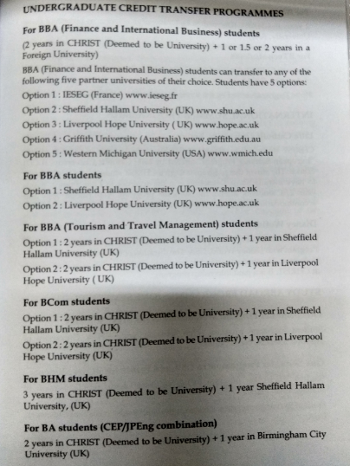

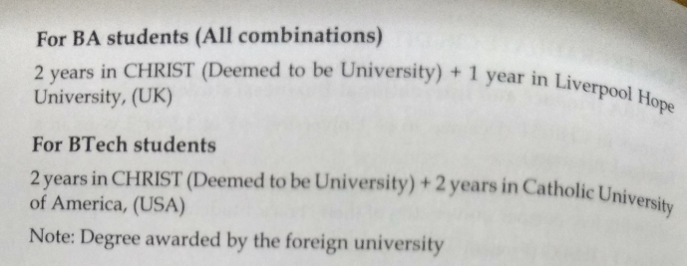

**Incoming students to CHRIST for one/two semesters**

* OIAS receives information from foreign universities about the number of student exchanges.
* OIAS sends the application form to partner universities or directly to the students (if students are not from partner universities).
* The information on courses/ credits/accommodation /insurance etc. are sent to the students.
* Student applies by sending the filled application form, copy of passport and transcripts.
* Invoices are raised for payment of administrative & accommodation charges. Tuition fees is charged only for students coming from non-partner universities
* Once the funds are received the Letter of invitation is issued for visa purpose.
* Students book the flight tickets after obtaining the visa.
* OIAS organizes pick up from the airport.
* Arrangements are made for the students to stay at CHRIST Guest House for one night.
* Once the student arrives on the campus, care is taken to make the student feel comfortable. The student is informed about the rules/regulations of CHRIST, The Handbook and the ID card is handed over to the student.
* OIAS coordinates with CSA for shifting the male students to the designated accommodation.
* OIAS coordinates with the Warden of Jonas Hall for female students.
* Police verification is done within two days of the arrival of the student.
* The Student is introduced to the mentor assigned by the Department.
* The mentor explains to the student about the academic matters such as; courses, classes, books, assignments, CIA’s, Exams, dress code, discipline etc.
* The student is allowed to finalize his course and subjects within one week of arrival
* The learning agreement is signed by the student after the course/subjects is finalised
* On completion of the course the transcript is prepared by OIAS.
* Transcripts are signed by the Director of OIAS and the Registrar.
* The transcripts are sent to the university or directly given to the student depending on the requirement.
* Feedback forms are collected from each student after the end of the course.

1. Summer Programmes

Below are some of the summer programs offered by CHRIST (Deemed to be University)

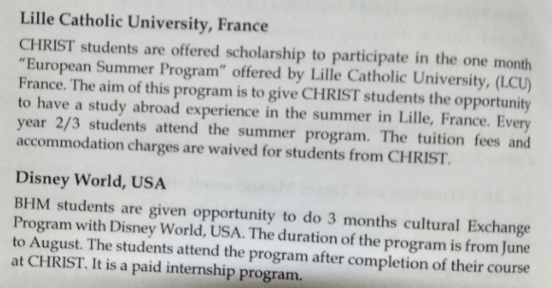

1. Study Abroad Programmes (One Semester)

Below are some of the study abroad programs offered by CHRIST (Deemed to be University)

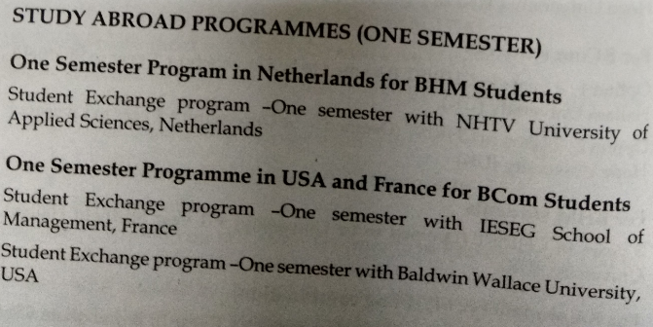

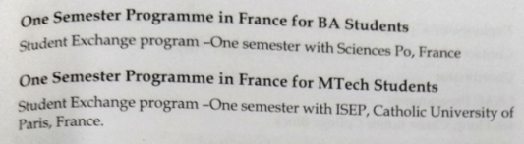

1. Customized Training Programmes

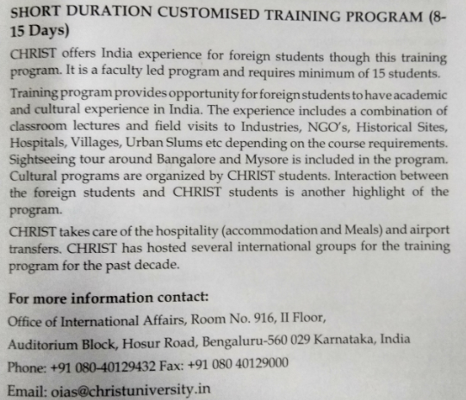

**Short duration training program (15/20 students along with faculty) (1-2 weeks)**

**Procedure followed for training programs:**

* OIAS corresponds with foreign universities by sending proposals with activities and the costs involved.
* OIAS and the foreign university agree upon the activities and the costs through consensus.
* Invoice is raised for the program
* Once the amount is received, the detailed itinerary is prepared for the training program
* Rooms are booked at the Guest House, venues are blocked for sessions, food and refreshments, appointments are taken for Company/NGO visits.
* OIAS sends invitation letters for obtaining visa.
* Once the group arrives the group is picked up from the airport and brought to CHRIST Guest House. The program is implemented as per the itinerary.
* OIAS co-ordinates with various persons associated with the program such as guest house caretaker, attendees, caterers, travel agent, drivers and resource persons etc. to make the program successful. Payments are made to all the persons involved in the implementation of the program.
* Feedback is collected at the end of the program.

1. University Studies Abroad Consortium (USAC)

For 30 years, USAC has provided university students with affordable, valuable study abroad programs and contributed to the internationalization of universities in the US and abroad; we currently have program locations in 25 countries with many locations unique for study abroad. Students from any university are welcome to participate; students from more than 800 universities around the world have studied on USAC programs over its thirty-year history.

USAC’s mission is to provide students with the opportunity to develop the knowledge, skills, and attitudes to succeed in the global society of the twenty-first century. We strive to provide an authentic, quality context in which students may grow into engaged citizens of the world, not only in the classroom but also through fieldtrips, integrated living and academic experiences, sports, internships, and volunteer and service learning opportunities.

Who is USAC?

USAC Central Office and Member University staff work closely with our on-site Resident Directors, Program Coordinators, staff, and faculty to ensure that students receive personalized care and support during your time abroad.

USACs Affiliate Universities

USAC is a non-profit consortium of 33 US universities. The Affiliate Universities serve a governance and strategic role for USAC, such as approving curriculum and issuing transcripts for USAC Specialty programs. Students need not attend an Affiliate University to participate on a USAC program. In fact, students from more than 800 universities worldwide have participated on USAC programs in its 30+ year history.

Why Study Abroad with USAC?

We pride ourselves on providing well-rounded, academically sound and credible programs in non-traditional locations or in unique parts of more traditional places. By choosing a USAC program, you have flexibility in the length and time of your study (short-term summer or January programs from three to ten weeks, to semester, trimester, or year options) and a wide range of courses to choose from, plus small class sizes, a multitude of disciplines taught in English, and language study at any level of proficiency from beginning to advanced and with no language prerequisite. Many of our locations have the option of intensive language study, where you can earn up to two years-worth of credit in one semester. USAC alumni give our programs a 94% recommendation rate.

USAC offers various programs at CHRIST (Deemed to be University), Bangalore which offers a wide array of informal and formal opportunities to enrich your time abroad and immerse yourself in your host culture, integrating with the local and global community. Internships, field study, and service learning courses offer for-credit opportunities to combine tangible experience and university credit. Volunteer opportunities, field trips and tours, activities with locals and as part of the host campus, cultural and sporting opportunities, and much more provide social and cultural context—both meaningful and enjoyable — to your studies abroad

Contact USAC

University Studies Abroad Consortium

Virginia Street Gym #5

1664 N. Virginia Street, MS 0323

Reno, NV 89557-0323

Toll-free: 1.866.404.USAC (8722)

Phone: 1.775.784.6569

Fax: 1.775.784.6010

Email : studyabroad@usac.unr.edu

Website : http://usac.unr.edu

1. Fact Sheet

Foreign students coming to CHRIST (Deemed to be University)



News, Conferences and Event

All news and events being conducted will be published here.

User should also have the possibility to register for the respective event, conference.

On registration an email should be sent to the respective organizing department and a copy to international office.

An option should be provided at the backend that enables any layman user to upload conference flyers, news, photos, videos, events etc prepared for promotion.

Social website links

All social links (Facebook, Twitter,etc) present on the CHRIST (Deemed to be University) website should be added

Contact

International Office

CHRIST (Deemed to be University) Main Campus

Hosur Road, Bengaluru - 560 029

Karnataka, India

**For Admission queries**

Email: isc.admission@christuniversity.in

Phone: +91 80 4012 9105, 9439

**For general & exchange program queries**

Email: oias@christuniversity.in and internationaloffice@christuniversity.in

Phone: +91 080-40129431/32 Fax: +91 080 40129000